Stress Analysis on Chassis

# Introduction

The chassis is a fundamental structure in the tow tractor, supporting all the components such as the motors, battery pack, electrical components, steering, and towing mechanism. Every vehicle chassis must be capable of carrying its own weight while towing additional loads while ensuring smooth movement and stability. The tow tractor chassis consists of a structural framework that supports the entire vehicle body, chassis frames are mostly made of structural members which are used in our design

# Chassis Design

## Design Considerations

When designing the chassis, we focused on two main goals:

* Supporting the weight of the components and towed loads
* Ensure stability and durability during operation

## Chassis Structure and Material Selection

For the chassis structure space frames were used in chassis design and a lightweight and strong materials, so a **steel alloy** was chosen. The selected structural element is **square tube** as it helps distribute weight efficiently while keeping the frame rigid and resistant to bending.

### Cad model

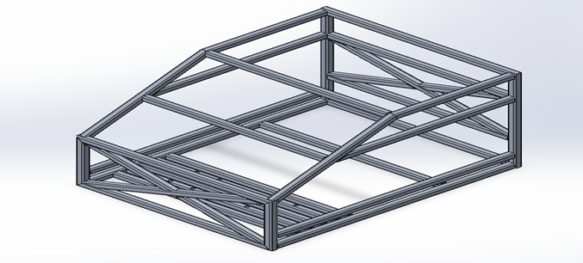

## Loads Acting on Chassis Frame

The chassis of your tow tractor will experience various types of loads during operation, but the ones with high impact will only be considered

* Chassis and components static weights  
  This load represents the constant weight of the chassis itself with all the onboard components. This stress on the frame and must be supported continuously, ensuring the chassis remains rigid and stable.
* Towing loads  
  When the tow tractor is engaged in towing, the additional weight of the towed load puts on an additional continuous stress on the chassis.
* Inertia Loads during acceleration and deceleration  
  These dynamic loads occur when the tow tractor starts moving or comes to a stop. During acceleration, overcoming friction to move the tractor and its load creates inertial stresses. Similarly, deceleration or braking generates forces that can impact chassis integrity.

By analyzing and optimizing for these specific scenarios using Finite Element Analysis the structure is can be ensured that it is robust enough to handle the operational stresses safely and efficiently.

The added loads to all different scenarios are

* Gravity and distributed mass of the components
* A force at the towing mechanism location
* 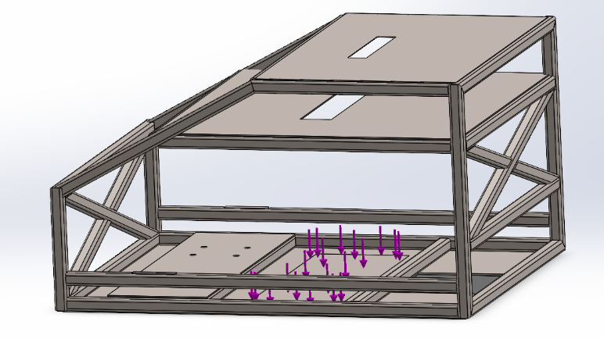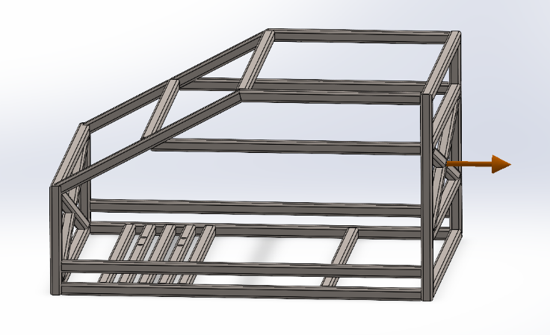Batteries mass on the bottom face

# Finite Element Analysis

## Fixation and Boundary Conditions

Alongside the previous loads discussed, the fixtures also play a critical rule to try and reflect the real-world condition.

Fixture loading where chosen to be

1. 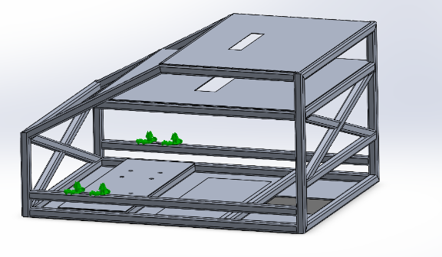**motor shaft bearings**

The chassis is secured at the motor shaft bearing housings, replicating how the motors are physically attached. This ensures the chassis experiences realistic reaction forces from the driving wheels.

1. 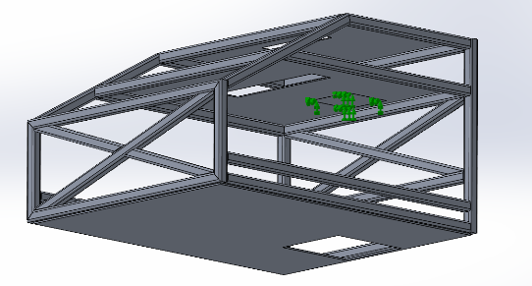**Steering wheel motor fixture**

The chassis is constrained at the steering motor mounting points, simulating the reaction forces from the steering mechanism.

## Results

### Bottom Corners Fixture

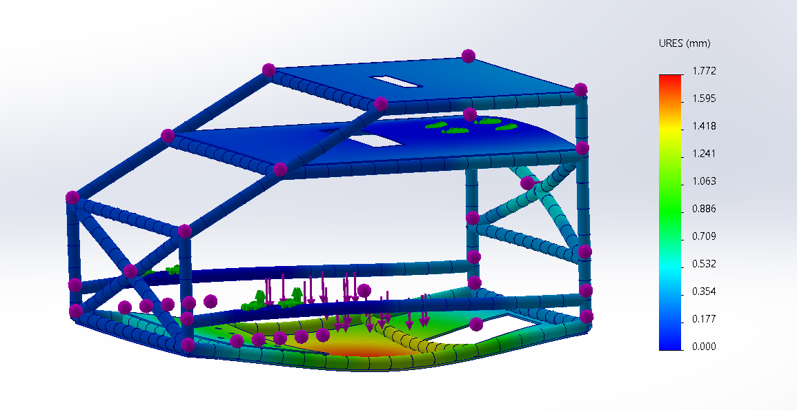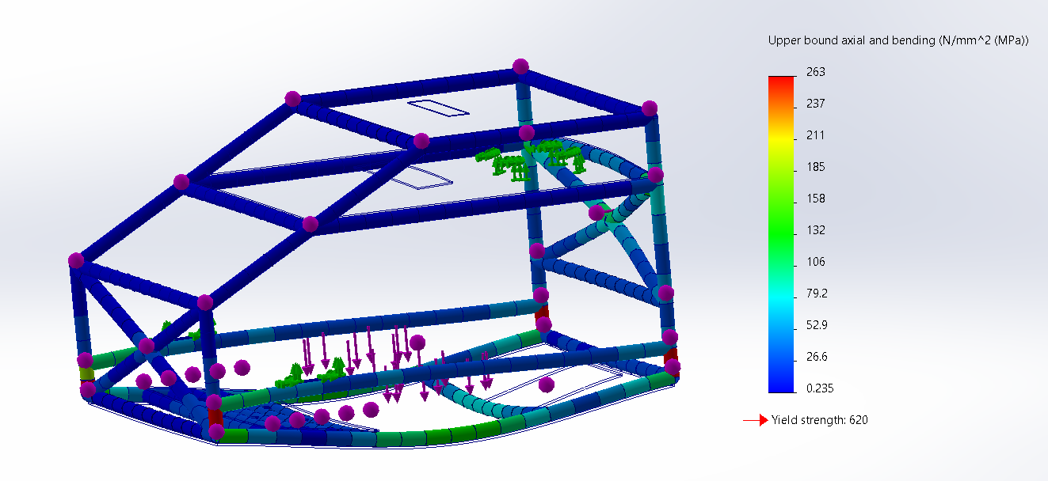

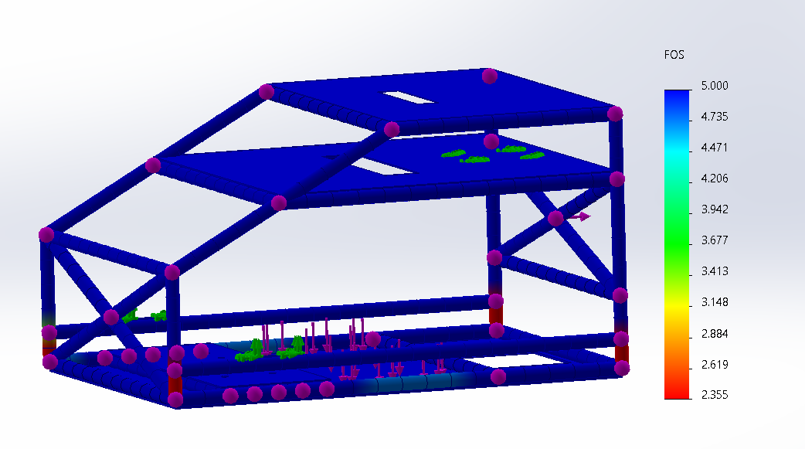

# Conclusion

From the applied simulation, we can conclude that the chassis design is structurally safe and capable of handling the applied loads. The stress levels remain well below the material's yield strength, and the overall factor of safety never drops below 2.3, ensuring a robust design.

The only concern observed is the deflection of the bottom surface, particularly in the area where the batteries are mounted. This may require additional reinforcement or design adjustments to minimize excessive deformation and maintain structural integrity.